Staff members
Staff members

H.van Eijkeren
General Practitioner
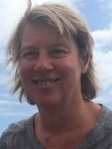
K.van Heusden
General Practitioner
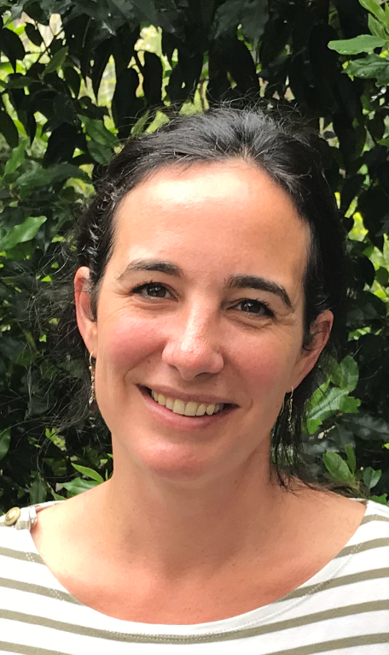
F.Strijers
General Practitioner
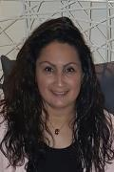
Patty Castrillon Pomeo
Assistant

Monique Bosman
Assistant
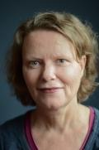
Nancy Slemmer
Assistant
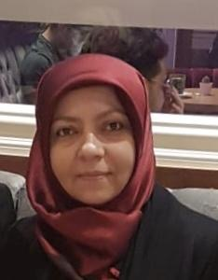
Nejla Aydin
Somatic Specialized Office Support

Catharina Teijema
Mental Health Specialized Office Support
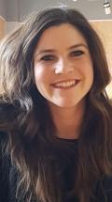
Lonneke Warnier
Youth Mental Health Specialized Office Support
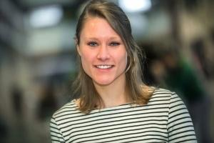
M.Bogerd
General Practitioner in Training
Powered by Pharmeon - Beheer

